- PROJECT TITLE PAGE
TEAM MEMBERS
Team Member | Student ID
N.Avinash Babu | 23341A05H2
P.Koushik | 23341A05H7
D.Avinash | 23341A0567
G.M.Charitha Sai | 23341A0574
K.Anuradha | 23341A05E2

Batch Number | 02
Course Name | GenAI
Instructor Name | Abdul Hameed
Submission Date

FULL SEMESTER INTERNSHIP
Academic Year: 2026–2027

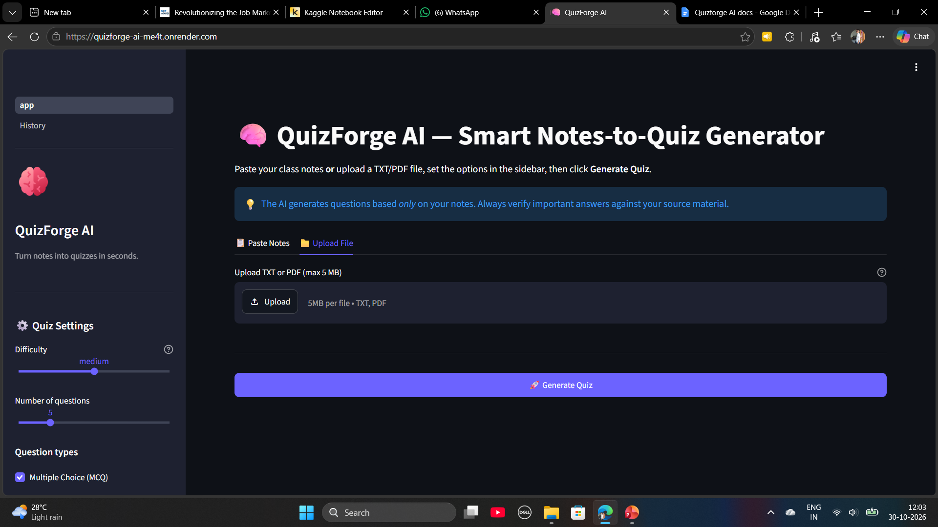

2. Abstract
QuizForge AI is an artificial intelligence-based application designed to automatically generate quiz questions from educational notes and study materials. Students often spend considerable time reading lengthy notes and preparing questions manually for examination preparation. This project aims to simplify the process by transforming study material into meaningful and interactive practice questions.
The application allows users to paste text or upload supported PDF and TXT documents. The content is processed and used to generate multiple-choice questions (MCQs), true/false questions, and short-answer questions. Users can select the difficulty level and the number of questions according to their requirements. The application also provides answer keys and brief explanations separately from the quiz questions.
The proposed system uses Python for application logic, Streamlit for the user interface, document-processing libraries for text extraction, and a large language model (LLM) API for generating questions and explanations. Optional components such as Natural Language Processing (NLP), Retrieval-Augmented Generation (RAG), text embeddings, and similarity analysis can improve retrieval and question quality when implemented.
QuizForge AI aims to reduce manual effort, support active learning, and provide students with an efficient tool for self-assessment and revision.
Keywords: Generative AI, Natural Language Processing, Quiz Generation, Large Language Models, Python, Streamlit, Educational Technology.

3. Introduction

3.1 Introduction
Artificial intelligence has become an important technology in modern education. AI-based applications can help students understand concepts, prepare learning materials, and evaluate their knowledge. One useful application of generative AI is the automatic creation of quiz questions from educational content.
Students frequently use textbooks, classroom notes, lecture materials, and PDF documents for examination preparation. Preparing practice questions from these resources manually requires considerable time and effort. QuizForge AI addresses this challenge by automatically generating questions from the content supplied by the user.
The application accepts study notes, processes the text, and generates different types of questions based on user-selected settings. It provides answers and explanations to help learners understand concepts and identify areas that need further revision.
The project combines a user-friendly web interface with AI-based text generation to make quiz preparation more convenient and accessible.

3.2 Problem Statement
Students often find it difficult to convert lengthy educational notes into effective practice questions. Manual preparation takes time, and creating questions at different difficulty levels requires additional effort.
Traditional question banks may not match the specific notes or syllabus being studied. Students may also need to prepare answer keys and explanations separately.
Therefore, there is a need for an automated system that accepts educational notes and generates relevant quiz questions, answers, and explanations according to user-selected requirements.

3.3 Objectives
The main objectives of QuizForge AI are:
- To develop an AI-powered application for automatic quiz generation.
- To accept pasted notes and supported PDF and TXT documents.
- To generate MCQs, true/false questions, and short-answer questions.
- To provide answer keys and explanations separately from quiz questions.
- To allow users to select difficulty levels and question counts.
- To reduce the time required for manual quiz preparation.
- To support self-assessment and effective examination revision.
- To validate user inputs and handle invalid documents appropriately.
- To improve question relevance by using the supplied study material as context.
- To provide a simple and accessible web interface.

3.4 Scope of the Project
QuizForge AI is designed for students, teachers, and teaching assistants who need to create practice questions from educational materials.
The project covers text input, document upload, text extraction, AI-based question generation, answer presentation, and basic error handling.
Additional features may include timed quizzes, automatic scoring, review of incorrect answers, quiz history, duplicate-question detection, and downloadable quiz files.
The application is intended for learning and revision. Generated questions should be reviewed before they are used in formal examinations or assessments.

3.5 Motivation
The main motivation behind this project is to make learning more interactive and reduce the effort involved in preparing practice questions.
Instead of repeatedly reading the same notes, students can generate questions, attempt them, and review the answers. This approach encourages active recall and helps learners identify concepts that require additional attention.
The project also provides practical experience in Python programming, generative AI, NLP, document processing, web application development, and software testing.

4. EXISTING AND PROPOSED SYSTEM

4.1 Existing System

In the existing approach, students generally prepare questions manually from textbooks and class notes. They may also use static question banks or general-purpose AI applications.

Manual question preparation requires reading and understanding the material, identifying important concepts, framing questions, and preparing answers.

Static question banks may contain useful questions, but they might not match the exact content of the user's study materials.

4.2 Limitations of the Existing System

Manual question preparation is time-consuming.

Different question formats require additional effort.

Static question banks may not cover specific study notes.

Preparing questions at different difficulty levels is difficult.

Answer keys and explanations may need to be created separately.

Repeated reading may not effectively reveal knowledge gaps.

Managing large amounts of study material can be challenging.

4.3 Proposed System

QuizForge AI provides an automated solution for generating quiz questions from educational notes.

Users can enter text or upload supported documents. The application extracts the text, validates the input, and prepares the content for AI processing. Based on the selected question format, difficulty level, and question count, the AI model generates relevant questions and corresponding answers.

The application presents the questions in a structured format and separates the answer key and explanations from the quiz.

The system also provides appropriate error messages for empty inputs, unreadable documents, unsupported files, and AI service failures.

4.4 Advantages of the Proposed System

Automated quiz generation from study notes.

Support for multiple question formats.

Customizable question count and difficulty.

Reduced manual preparation effort.

Convenient examination revision.

Improved self-assessment opportunities.

Potential for reusable quizzes and downloadable results.

Extensibility through additional AI and NLP features.

5. TECHNOLOGIES USED

5.1 Python
Python is the primary programming language used to implement the application's backend logic, document processing, input validation, AI integration, and quiz-generation workflow.

5.2 Streamlit
Streamlit is used to develop the interactive web interface. It allows users to upload notes, configure quiz settings, generate questions, and view results.

5.3 Groq API
The Groq API can connect the application to a supported large language model for generating quiz questions, answer keys, and explanations.

5.4 Google Gemini API
The Gemini API can provide an alternative AI model for question generation and explanation, depending on the implementation and configuration.

5.5 Natural Language Processing (NLP)
NLP techniques can help process educational text, analyze question content, identify important concepts, and improve the quality of generated quizzes.

5.6 Text Embeddings
Text embeddings convert text into numerical vectors that represent semantic information. They can be used to compare questions and retrieve relevant passages from study material.

5.7 Cosine Similarity
Cosine similarity measures the similarity between two vectors. It can help identify questions that may be duplicates or semantically similar.

5.8 Retrieval-Augmented Generation (RAG)
RAG retrieves relevant passages from supplied study material and provides them as context to the AI model. This can help make generated questions more relevant to the source notes.

5.9 Vector Store
A vector store manages embeddings and supports semantic retrieval of relevant text chunks. It is useful when the project implements an embedding-based retrieval pipeline.

5.10 Agentic AI
Agentic AI can coordinate multiple stages of the workflow, including content retrieval, question generation, output validation, and controlled retries. This component is applicable when the project implements such an orchestration mechanism.

5.11 PDF/TXT Processing
Document-processing libraries extract readable text from uploaded PDF and TXT files. Scanned PDFs may require optical character recognition (OCR).

5.12 SQLite
SQLite can store quiz history, generated questions, user responses, and scores when persistent local storage is implemented.

5.13 Pandas and CSV/TXT Export
Pandas can organize question and result data. CSV and TXT export functionality can allow users to download generated quizzes and answer keys.

5.14 Pytest
Pytest can be used to automate tests for input validation, text processing, quiz generation, retrieval, and error handling.

5.15 python-dotenv and Environment Variables
Environment variables can be used to store API keys and configuration values outside the main source code. A local .env file should be excluded from version control.

5.16 Git and GitHub
Git provides version control, while GitHub hosts the source code and project documentation. These tools support project maintenance, code history, and collaboration.

5.17 Render or Streamlit Community Cloud
A supported hosting platform can be used to deploy the application online. The selected platform must be compatible with the application's dependencies and configuration.

6.SYSTEM REQUIREMENTS

6.1 Hardware Requirements
- Processor: Intel Core i3 or equivalent and above.
- RAM: Minimum 4 GB; 8 GB recommended.
- Storage: Sufficient space for Python, dependencies, source code, and sample documents.
- Internet connection: Required for hosted AI API access.
These are suggested development requirements and may vary depending on the implementation.

6.2 Software Requirements
- Operating System: Windows, Linux, or macOS.
- Programming Language: Python.
- Frontend Framework: Streamlit.
- AI Provider: A supported LLM API.
- Document Processing: A suitable PDF text-extraction library.
- Development Environment: Visual Studio Code or another Python IDE.
- Version Control: Git and GitHub.
- Testing Framework: Pytest, if automated testing is implemented.
- Database: SQLite, if quiz history is stored.
- Deployment Platform: A compatible hosting service, if online deployment is required.

7. SYSTEM ARCHITECTURE

7.1 Architecture Overview
QuizForge AI follows a modular architecture in which the user interface communicates with the processing modules, and the AI service generates quiz content.
The main components are:
- User interface.
- Input validation.
- Document processing.
- Quiz configuration.
- AI question generation.
- Output validation.
- Results presentation.
- Optional storage and export components.
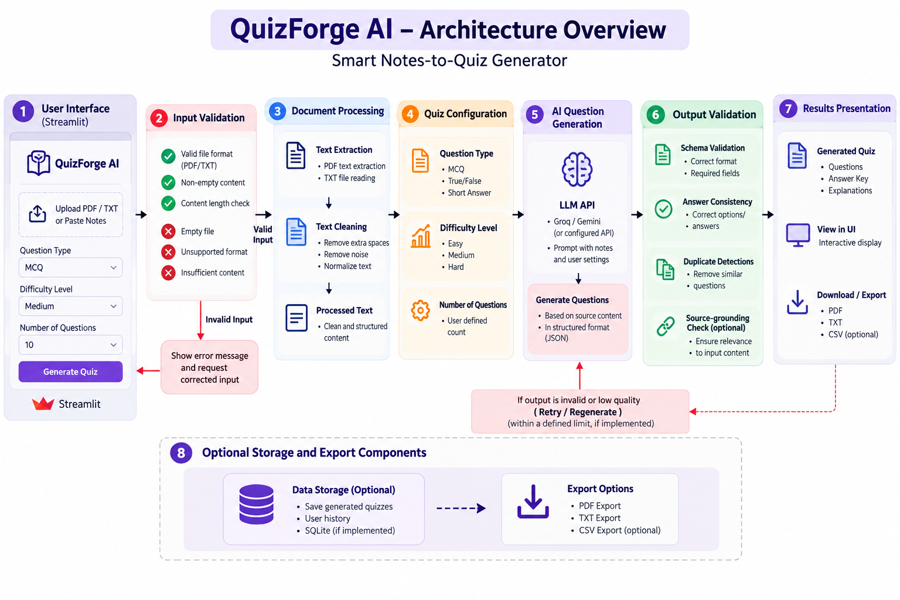

7.2 Workflow
Step 1: User Input
The user pastes educational notes or uploads a supported PDF or TXT file.
Step 2: Input Validation
The system checks the input for missing content, invalid file formats, and processing limits.
Step 3: Text Extraction
For uploaded documents, the application extracts readable text.
Step 4: Quiz Configuration
The user selects the question format, difficulty level, and number of questions.
Step 5: Prompt Preparation
The application prepares instructions containing the source notes and selected quiz settings.
Step 6: AI Question Generation
The configured LLM generates questions, answers, and explanations.
Step 7: Output Validation
The system checks the generated response for missing fields, malformed output, and potential duplicates where supported.
Step 8: Results Presentation
The application displays the generated quiz and presents the answer key and explanations separately.

7.3 Architecture Flow Diagram
User Input → Input Validation → Text Extraction → Quiz Configuration → AI Question Generation → Output Validation → Quiz Display
Optional components include a vector store for retrieval, SQLite for history, and a testing framework for validation of the application's behavior.

8. TESTING AND EVALUATION

8.1 Testing Objectives
Testing verifies that the application accepts valid inputs, processes documents correctly, generates quiz content, and handles failures appropriately.

8.2 Test Cases
Test ID | Test Scenario | Expected Result
TC01 | Enter valid study notes | Quiz questions are generated
TC02 | Upload a valid text-based PDF | Text is extracted and processed
TC03 | Upload a valid TXT file | Text is read successfully
TC04 | Submit empty notes | A validation message is displayed
TC05 | Upload an unsupported file | The file is rejected with a clear message
TC06 | Upload an unreadable scanned PDF | The system reports that readable text is unavailable
TC07 | Provide lengthy study notes | The system processes the content within configured limits or explains the restriction
TC08 | Select different difficulty levels | The generated questions reflect the selected level
TC09 | Select different question formats | The requested question format is generated
TC10 | Simulate AI service failure | A readable error message is displayed
TC11 | Generate similar questions | Duplicate detection flags potential duplicates where implemented
TC12 | Check generated answers | Answers are reviewed against the source notes
These are proposed test cases. Actual results should be recorded after running the application.

8.3 Evaluation Criteria
The application can be evaluated using the following criteria:
- Relevance of questions to the source notes.
- Correctness of answers and explanations.
- Compliance with the requested question count.
- Clarity and uniqueness of questions.
- Appropriate difficulty level.
- Reliability of text extraction.
- Input validation and error handling.
- Ease of use and responsiveness.
Numerical performance metrics should be included only after actual evaluation.

9. APPLICATIONS
QuizForge AI can be used in several educational scenarios.
- Student Revision: Students can convert class notes into practice quizzes.
- Examination Preparation: Learners can use generated questions to revise important concepts.
- Teaching Assistance: Teaching assistants can prepare draft questions from study material.
- Self-Assessment: Students can attempt questions and check the answer key.
- Digital Learning: Educational platforms can use the concept to support interactive learning.
- Personalized Practice: Learners can select question formats and difficulty levels based on their requirements.

10. LIMITATIONS
Although QuizForge AI provides an automated approach to quiz generation, several limitations remain.
- AI-generated questions may contain errors or unsupported information.
- The quality of questions depends on the source notes and AI model.
- Scanned PDFs may require OCR support.
- Very long documents may exceed model context or API limits.
- AI provider outages and rate limits may interrupt processing.
- Incomplete notes may not contain enough information for useful questions.
- Generated questions may not cover every important topic.
- Difficulty levels may not always match the user's expectations.
- Similarity checks may miss duplicates or incorrectly flag different questions as similar.
Users should review generated questions and answers before relying on them for formal assessments.

11. CONCLUSION
QuizForge AI is an AI-powered application designed to transform educational notes into customized quiz questions. It combines Python, Streamlit, document processing, and generative AI to simplify the preparation of practice questions.
The application supports a workflow in which students provide study material, select quiz settings, generate questions, and review answer keys and explanations. By reducing manual question-preparation effort, the system aims to make examination revision more interactive and convenient.
The quality of the results depends on the source material, AI model, and validation mechanisms. Proper testing and review are therefore important for reliable educational use.
QuizForge AI also provides practical experience in generative AI integration, NLP, document processing, web development, testing, and deployment. With further improvements, the application can be extended into a more comprehensive learning and self-assessment platform.

